How to Change a User's Password
Requires Admin Level

After login, you will land on the Add Order page. Click on Dashboard on the top right
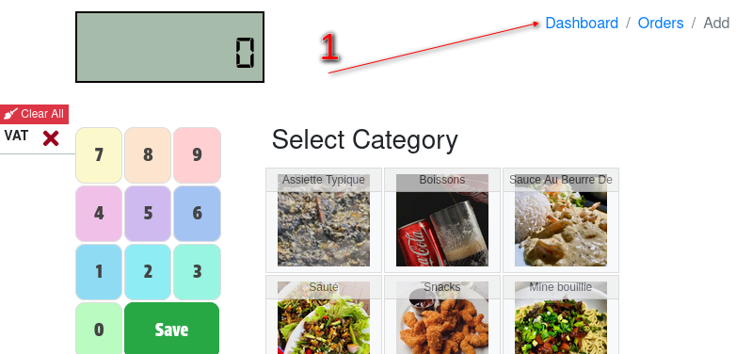
Now click on Back Office
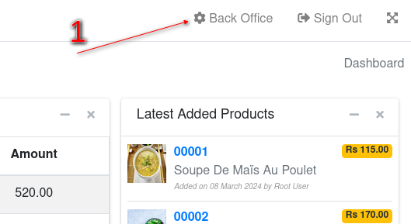
Navigate to Users > Listing
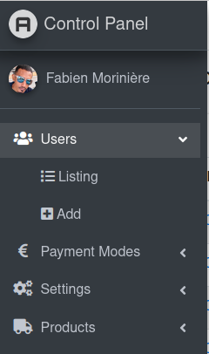

Click on edit for the user to want to edit or change their password
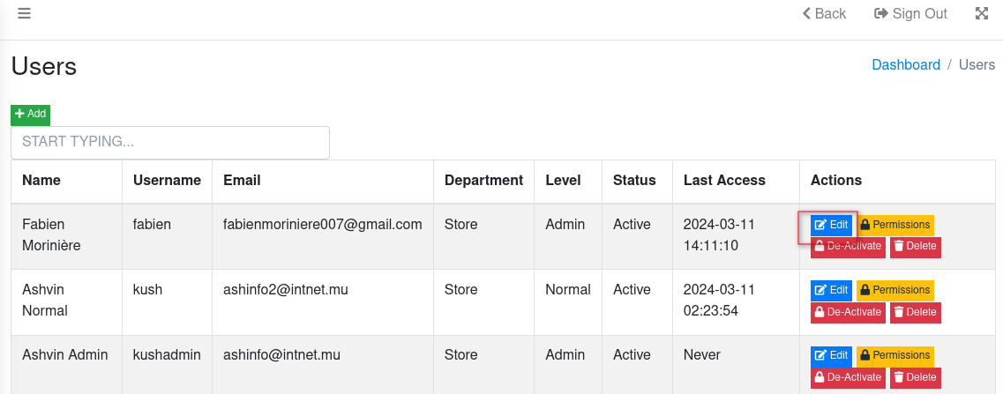
Now enter your password twice
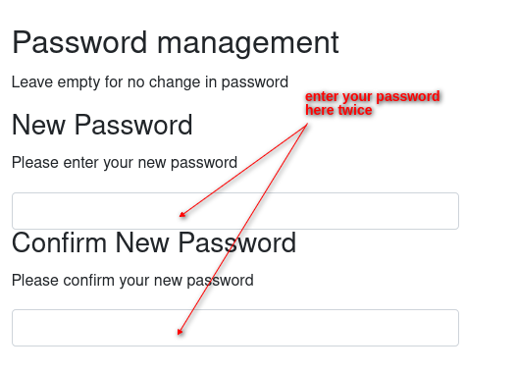
Click on Update to save your changes

